Check List for WFH

|  |  |  |
| --- | --- | --- |
| **Application** | **Environment** | **URL** |
| Zeppelin | PRD | <http://usnencpl075.nmcorp.nissan.biz:9995/> |
| DIH | PRD | <http://10.78.11.31:18080/dih-console/login.jsp> |
| DIH Non | PRD | <http://10.78.11.32:18080/dih-console/login.jsp> |
| Oozie | PRD | <http://usnencpl075.nmcorp.nissan.biz:11000/oozie/> |
| Oozie | STG | <http://usnencpl077.nmcorp.nissan.biz:11000/oozie/> |
| Ambari | PRD | <http://usnencpl075.nmcorp.nissan.biz:8080/#/login> |
| Tableau | PRD | <https://tableau.na.nissan.biz/#/site/TCS/datasources> |
| Solr | STG | <http://usnencpl091.nmcorp.nissan.biz:8983/solr/#/> |
| EQUIP | PRD | <https://datamgtanalytics.na.nissan.biz/> |
| Confluence |  | <https://confluence.na.nissan.biz/> |
| Jira |  | <https://jira.na.nissan.biz/> |
| Zoom |  | <https://nissan-usa.zoom.us/j/8647358496> |
| ServiceNow |  | <https://nnanissan.service-now.com/> |

SQL Developer:

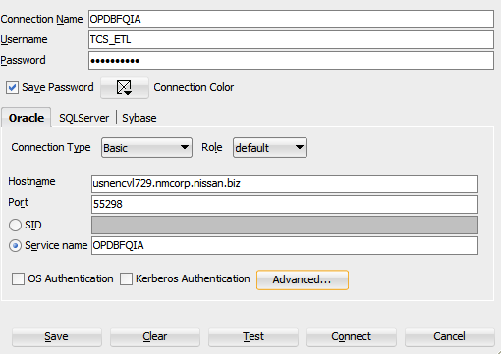

|  |  |  |  |  |  |
| --- | --- | --- | --- | --- | --- |
| **ConnectionName** | **Username** | **Password** | **Hostname** | **Port** | **Servicename** |
| OPDBFQIA | TCS_ETL |  | usnencvl729.nmcorp.nissan.biz | 55298 | OPDBFQIA |
| OPDBFQIA | TCS_ETL |  | usnencvl729.nmcorp.nissan.biz | 55298 | OPDBFQIA |
| OPDBFQIA | TCS_ETL |  | usnencvl729.nmcorp.nissan.biz | 55298 | OPDBFQIA |
| OPDBFQIA | TCS_ETL |  | usnencvl729.nmcorp.nissan.biz | 55298 | OPDBFQIA |
| OPDBFQIA | TCS_ETL |  | usnencvl729.nmcorp.nissan.biz | 55298 | OPDBFQIA |
| OPDBFQIA | TCS_ETL |  | usnencvl729.nmcorp.nissan.biz | 55298 | OPDBFQIA |

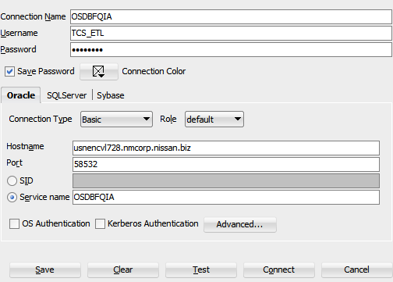

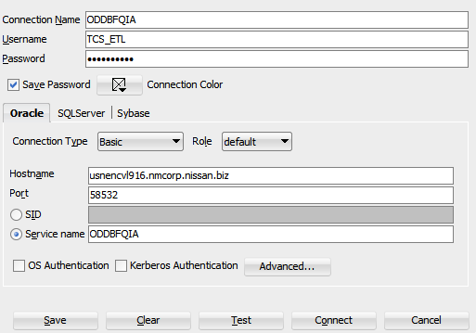

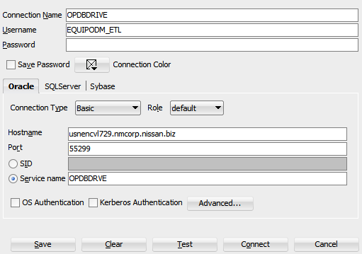

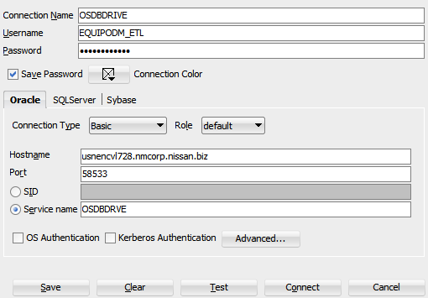

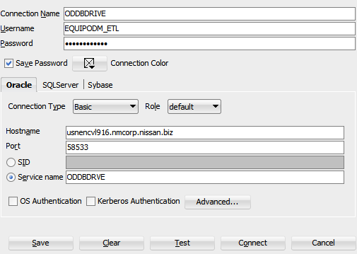

Informatica Configurations :

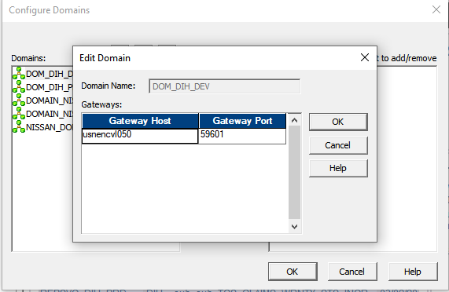

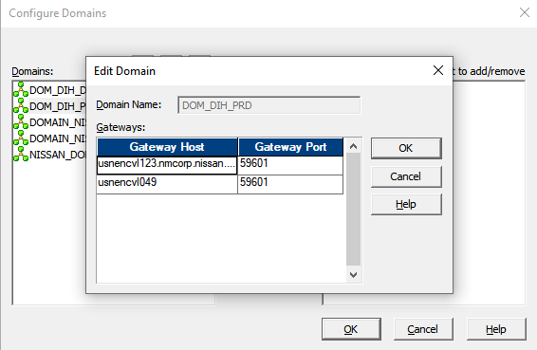

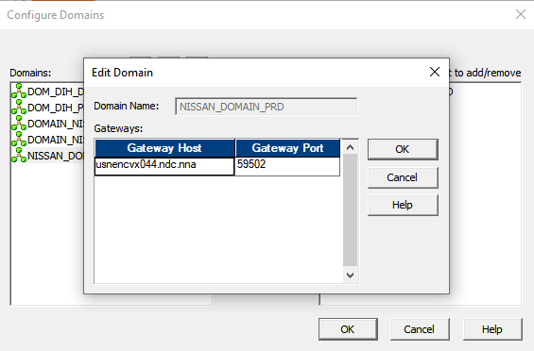

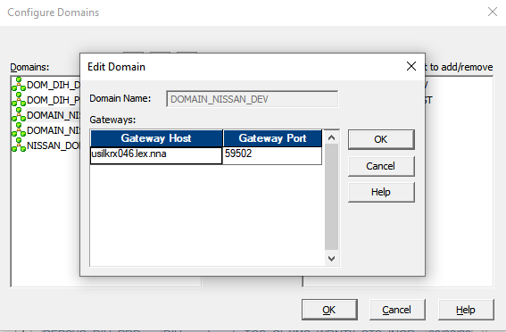

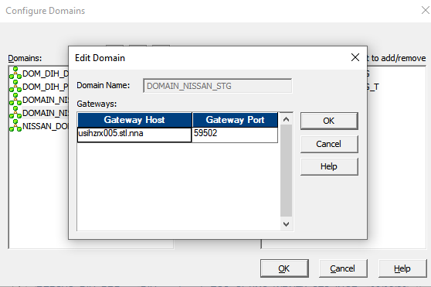

|  |  |  |
| --- | --- | --- |
| UNIX IPs: – port 22 | | |
| Informatica | PRD | 10.78.11.21 |
| Dev | 10.78.39.67 |
| STG | 10.78.39.100 |
| Hive | Dev | 10.79.32.133 |
| PRD | 10.79.32.129 |
| STG | 10.79.32.131 |